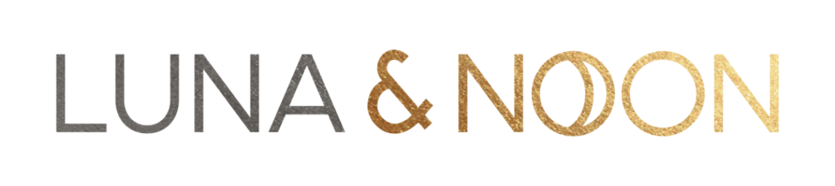
RETURNS / EXCHANGES FORM
We’re sorry to hear that you want to return your purchase. Please fill in the below to help us do better next time.
Or if you would just like to exchange your item, please complete this form and email us at hello@lunaandnoon.com to help facilitate your exchange.
Items must be unworn and returned with all labels intact and returned in their original packaging.
Customer Order No:
Product Name | Product size | Reason for return (please select from the below)

Reason for return options
- Fit
- Doesn’t look like the image
- Quality
- Doesn’t suit
RETURNS / EXCHANGES ADDRESS:
Please post your item(s) and your returns/exchanges form to the following address. Remember to keep your proof of postage safely should we need it.
RETURNS
LUNA & NOON
41 THE FAIRWAY
NORTHWOOD
MIDDLESEX

Once we receive your return, it can take up to 10 days to process. Following this, your refund should show in your account within 2-5 days. Please note payment for your refund will be given back onto the account/card from which the purchase was made.
For international refunds, please allow more time as some banks may take longer to process.
www.lunaandnoon.com

